**COVID PULSE: A REALTIME WEB-BASED APPLICATION FOR INCLUSIVE  
DIGOS CITY COVID-19 INFORMATION CATALOG AND TRACKING**



**COR JESU COLLEGE, INC.**

Science, Technology, Engineering, and Mathematics (STEM)

Senior High School Department

Digos City

**CABRERA, AIDRE LOVE, S.**

March 2022

**COVID PULSE: A REALTIME WEB-BASED APPLICATION FOR INCLUSIVE  
DIGOS CITY COVID-19 INFORMATION CATALOG AND TRACKING**

A Science Investigatory Project

Presented to   
The Faculty of Cor Jesu College, Inc.

Basic Education Department

Digos City

In Partial Fulfillment of the Requirements in

Practical Research 3

by

CABRERA, AIDRE LOVE, S.

March 2022

# TABLE OF CONTENTS

TABLE OF CONTENTS 3

CHAPTER I INTRODUCTION 1

Theoretical and Conceptual Framework 1

Statement of the Problem 1

Hypothesis 1

Significance of the Study 1

Scope and Limitation of the Study 1

Definition of Terms 1

CHAPTER II REVIEW OF RELATED LITERATURE 1

Research Design 1

Locale of the Study 1

Materials and Methods 1

Measures 1

Procedure 1

Data Analysis 1

CHAPTER III METHODS 1

CHAPTER IV RESULTS AND DISCUSSION 2

CHAPTER V SUMMARY, CONCLUSIONS, AND RECOMMENDATIONS 2

CHAPTER I  
INTRODUCTION

## Theoretical and Conceptual Framework

The study that is going to be conducted could be best viewed with the Viewpoint which provided a framework developed by Whitelaw et al. (2020). This framework was developed for the purpose of highlighting the various ways digital technology could be integrated with a pandemic and management response, in this case, the COVID-19 pandemic. The viewpoint argued that those countries who have successfully flattened the incidence curves and maintained a low mortality rate have the characteristic of adopting digital technology and made it part of their COVID-19 pandemic policy and overall response (Whitelaw et al., 2020).

Additionally, the framework emphasized that there are many ways digital technology can be used as an initiative to pandemic preparedness and response. Digital technology can be utilized as a tool such as Contact Tracing, Quarantine and Self-isolation, Screening for Infection, Clinical Management, Planning and Tracking, and Medical Supplies. Furthermore, in every category of the type of utilization, it has its respective functions, advantages, and disadvantages. Therefore, the research project is adopting the Tracking technology wherein the COVID-19 Pulse, the digital technology that is integrated for the purpose of COVID-19 pandemic response, is aimed to provide epidemiological insights and monitor the COVID-19 situation in real-time. With this, the study had acknowledged the framework postulate that tracking technology may be advantages since it paves the way for an actionable and reliable COVID-19 information, visualization of the COVID-19 virus and pandemic, guides and resource allocation, and dissemination of COVID-19 forecasts. However, the framework also postulated that although tracking technology is advantageous, it is without its disadvantages. One highlighted disadvantage of integrating dashboard technology as part of the COVID-19 pandemic response is the high costs and demand for maintainability.

**Theoretical and Conceptual Framework**

## Objectives of the Study

This research project aims to expand the COVID-19 information system of Digos City through the development of a real-time tracking COVID-19 web-based dashboard called "COVID Pulse" for Digoseños to ensure that they are prioritized by enabling it to be feasible for them to retrieve updated COVID-19 information in real-time. Specifically, the project objectives of the study are following:

1. To gather the necessary requirements and its method to be employed in developing the COVID Pulse web-based dashboard.
2. To develop the COVID Pulse web application frontend, middleware, and backend.
3. To embed and visualize the COVID-19 data from data repositories and APIs.
4. To develop an accessible Digos City COVID-19 web-based application that provides:
   1. A dynamic and real-time comprehensible epidemiological indicators
   2. A user-friendly interactive user experience and interface
   3. Brief narratives to summarize and interpret displayed data
   4. Relevant news updates related to COVID-19 situation

## Significance of the Study

This area of study is important since effective public health communication plays a crucial part in controlling the COVID-19 pandemic. As the COVID-19 virus continued to ravage the world, adequate, reliable, timely, and relevant information became a highly essential resource for people to be consistently informed. Fortunately, healthcare authorities could communicate to the public effectively by digitizing information systems (Bernardino & Bacelar Nicolau, 2020). That is why COVID-19 information systems are more critical than at any other time for handling data and information at the pace required by the ambiguity of the COVID-19 situation. Consequently, many have developed approaches to improve and expand the COVID-19 information system and public communication (Clarke et al., 2021; World Health Organization & Others, 2020). Health information systems were expanded at an unprecedented pace due to the urgency of the worldwide need for COVID-19 data and the widespread internet penetration (Ivanković et al., 2021; Max Roser & Ortiz-Ospina, 2022). That is because COVID-19 information systems may support decision-making and help individuals adapt their health behaviors to the crisis.

COVID-19 information systems make it easier to prioritize healthcare, access, and response for those most in need by making it possible to access and share data immediately, expeditiously, and in a coordinated manner (World Health Organization, 2020). Another way of expanding the information system is by adopting web-based COVID-19 dashboards as a medium for effective public communication of the data. Accessible web-based dashboards for COVID-19 data have become quite prominent and necessary. It provides essential empirical support for making the most informed decisions feasible and improving awareness of safety measures for Digoseños (World Health Organization, 2020). Hence, the primary rationale for the topic of interest is to provide an exclusive and area-specific data communication for Digoseños since there is a need for expansion of the Digos City COVID-19 Information System. Researching this topic and developing a COVID-19 dashboard that will contribute to the improvement of a robust information system in Digos city is necessary, if not, crucial as part of the effort to control the COVID-19 pandemic.

COVID Pulse will be developed for the general public and can be accessible through the internet. However, the significance of this project will directly benefit the following:

**Public Health Authorities.** Public health authorities, especially in the locality, need to be proposed with a real-time COVID-19 tracking dashboard to communicate the epidemiological insights in Digos City. Disseminating COVID-19 insights through social media lacks actionable and real-time qualities, rendering the COVID-19 information system for public communication insufficient. Therefore, public health authorities need a complementary means of effectively communicating the COVID-19 epidemiological data to the public. One of the ways it can be done is by developing a real-time COVID-19 dashboard that includes the context of the locality. It is through the proposal of a COVID-19 web-based dashboard that allows the public health authorities to disseminate the essential COVID-19 insights to the public.

**Digoseños.** The lack of access to real-time COVID-19 insights incapacitate the health-decision making of Digoseños in the context of the COVID-19 situation. Therefore, a real-time dashboard visualization of the COVID-19 data proposal is a useful approach to address the general public of Digos City's need for comprehensive, timely, and accurate COVID-19 related information, which will allow them to make critical health-informed decisions.

**Researchers.** Although it is improbable that this study will be published, researchers hereafter who have the same research of interest, that is the adoption of technology for pandemic response, can benefit from this research study. That is because the development journey and activity taken will provide further insights, recommendations, and implications. Furthermore, the study can also be anchored for their studies to further synthesize and support their upcoming studies. Lastly, they can also utilize this study to develop a much better methodology in developing a real-time COVID-19 dashboard prototype.

**Open-Source Community.** The will benefit the open-source community since the repository for COVID-19 Pulse will be published on GitHub, which is version-control and collaboration online platform for developers. Hence, every aspect of the project from the frontend, middleware, and backend source code as well as the manuscript and documentation will be publicly available. With that, anyone can contribute or even fork the project for further improvement of the COVID Pulse. Lastly, even though the project will be available publicly, there will be certain limitations and restrictions when it comes to the distribution and modification of the COVID Pulse project.

## Scope and Limitation of the Study

The study will mainly focus on the contribution of expanding the COVID-19 information system of Digos city through the development of a COVID-19 web-application called COVID-19 Pulse. The researcher will ensure that the designed and developed prototype will meet all the designed and devised requirements. In other words, it must at least be barely functional as well as provide answers in the statement of the problem. Additionally, the researcher will consider the feasibility in terms of technical, economic, legal, and scheduling feasibility aspects of the project. This will be further analyzed in the pre-development feasibility analysis stage. Strictly speaking, the project will only adopt available technologies that is also technically and economically feasible and possible for the researcher to deal during the development of the COVID Pulse. Nevertheless, the researcher will also consider limiting the project to develop a prototype given the time constraints. Since given that the project with a scope of deploying a perfect web-application that is an efficient, accurate and error-free will make it unfeasible to conduct. Especially in the frontend development where the consensus has attested that it is an arduous process. Lastly, the researcher will set a timeframe for the development process from February 2022 to May 2022.

## Definition of Terms

**COVID-19 PULSE.** It is the opted web application name of the COVID-19 realtime web-based application. The name was inspired by the Official School Publication of Cor Jesu College Basic Education Department called “Pulse”.

**REALTIME.** It refers to the feature of the COVID Pulse web application that delivers information in the time during it was requested. In other words, it can be describe as a mechanism of the system where it is available and immediately provides the necessary COVID-19 related information. This could also mean that the information that is delivered is up-to-date according to the COVID-19 dataset reports. So COVID Pulse can be called realtime if it delivered the data relative to the newly reported data from the primary source.

**WEB-BASED APPLICATION.** It refers to the type of which the COVID Pulse application program was designed. Unlike the software applications where it is stored in the client’s device, COVID Pulse is designed to be accessed through the internet and stored in a remote server, and can be used using a web browser.

**INCLUSIVE.** It refers to the main aspect of the COVID Pulse web-based application where it also delivers COVID-19 information and insights relative to the locality for Digoseños. Unlike the other COVID-19 web applications where it either is abstract, excludes, or lacks the coverage of the necessary and relevant COVID-19 data in the locality.

**DIGOS CITY.** It refers to the aimed locality of which the COVID Pulse will be specifically deployed. The City of Digos is located in Davao Del Sur, Philippines, and the demonym for the citizens living in the city are called Digoseño.

**COVID-19 INFORMATION.** It refers to the information that is related to the COVID-19 pandemic situation, severe acute respiratory syndrome coronavirus 2 (SARS-CoV-2), Coronavirus Disease 2019 (COVID-19), COVID-19 Vaccination, COVID-19 Policies, and many other COVID-19 related information that is relevant and timely. Additionally, these informations can come in a form of news articles, updates, and epidemiological insights.

**CATALOG.** It refers to the feature of categorization of the COVID-19 information that will be provided on the end-users of COVID Pulse web application.

**TRACKING.** It refers to the feature of the COVID Pulse web application that provides an realtime and up-to-date monitor of the COVID-19 active cases, recoveries, deaths, vaccination, and the overall situation of the COVID-19 pandemic.

CHAPTER II  
REVIEW OF RELATED LITERATURE

CHAPTER III  
METHODS

## Research Design

This research project will employ a Software Development Life Cycle (SDLC) model called Agile. The most basic SDLC model adopted is Waterfall for software and web development (Chandra, 2015; Kumar Pal, 2018). However, adopting the classical waterfall model in a real-world web application development project is impractical since it is idealistic and challenging to implement (Kumar Pal, 2018). Moreover, the sequential nature of the Waterfall SDLC made it unsuitable for this project. That is why the project development methodology will adopt another SDLC model called Agile Model. The said framework is different from the expected linear sequential life cycle of the Waterfall Model.

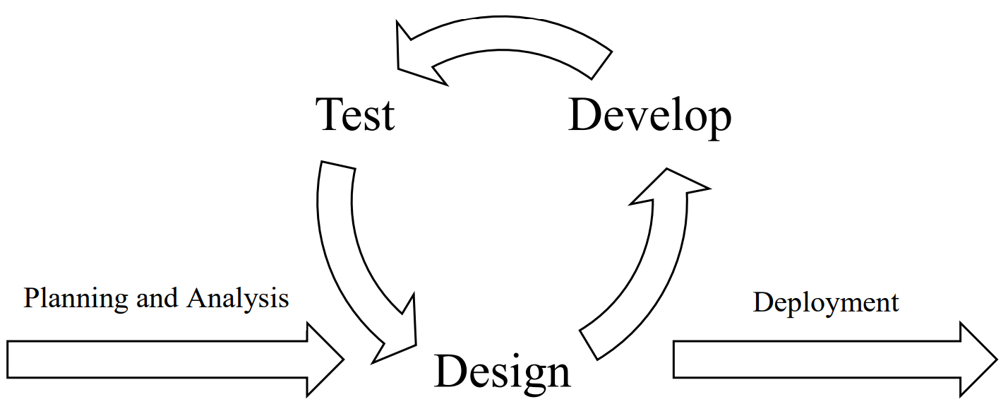

***Figure 2.*** Agile Software Development Life Cycle Model

The primary purpose of the Agile Software Development model is to facilitate quick project completion adaptively. The salient nature of Agile SLDC will allow the researcher to adapt to the unexpected circumstances in the development process due to its iterative and incremental nature (Figure 1). In other words, the researcher can make it up as the project goes along with the Agile Model. Whereas the Waterfall SLDC model, the researcher will structure everything before starting the project. However, with no adaptability due to its linear sequential flow, any erroneous prospects and consequences will be disregarded and not be rectified (Chandra, 2015). That is why the researcher will adopt the Agile Model since it is the most suitable SLDC model that allows the researcher to employ the advantages such as adaptability, efficiency, flexibility, incremental and continuous iteration, the high success rate with less time requirement, risk-reduction, and the elimination of cost (Dixit et al., 2020). Thus, the envisioned project stages will adopt the Agile Model.

## Locale of the Study

The study will be conducted in the City of Digos, a capital of 8002 Davao Del Sur, Davao Region XI, Mindanao, Philippines. Furthermore, the locale of the deployment of the study will also be located in the City of Digos. The locale was purposefully chosen since the research problem as well as the research gap was uncovered in the said locale. Moreover, the target users for the deployment of COVID Pulse are the Digoseños. The word “Digoseños” is a plural form of a demonym word of the citizens and residents who live in the City of Digos located in Davao Del Sur, Philippines, called Digoseño. Additionally, the COVID Pulse project is also aimed to inscribe the Cor Jesu College, Inc. Institution.

## Materials and Methods

The protocol defined for the study will be strictly adhered unto the Agile Software Development Life Cycle Model. This section will include the stages of the adopted model: Planning and Analysis, Design, Develop, Test, and Development.

**Planning and Analysis Stage.** This is the pre-development phase. It is where the researcher will emphasize the procedures that assess the requirements of the COVID pulse web application development to satisfy the project objectives. One of the things that are initially done in this stage will be the Feasibility Analysis, wherein all the relevant factors such as the Technical, Economic, Legal, and Scheduling (TELOS) are considered (McLeod, 2021). Also, this stage consists of the consideration of the potentially conflicting needs and consequences in the development process. It also allows the researcher to document, assess, verify, and maintain the protocol of the development procedure.

**Partial Feasibility Analysis.** For the partial Feasibility Analysis in the pre-development phase, this project requires an overhaul of the web application and responsive web design for the development and setting up of the project.At present, the technical, operational, and scheduling feasibility will only be considered anchoring from the Technical, Economic, Legal, and Scheduling (TELOS) framework (McLeod, 2021). The economic, human, legal factor feasibility will be excluded from consideration since it is still equivocal or unnecessary considering the project is a straightforward web application. Furthermore, the project does not require any budget because most of the resources, apart from the physical tools and human resources needed, such as electricity and computer, are accessible and open-source. The researcher has partially determined the technical resources and applicability to the COVID Pulse development requirements.

In terms of the hardware requirements, besides two computers and an internet connection, the basic hardware requirements for the COVID Pulse project can be needless since the researcher will utilize the Google Firebase service to host the COVID pulse web application. However, the COVID Pulse project will still use another computer to test the web application. Hence, the researcher the hardware requirements to set up a server can be optional.

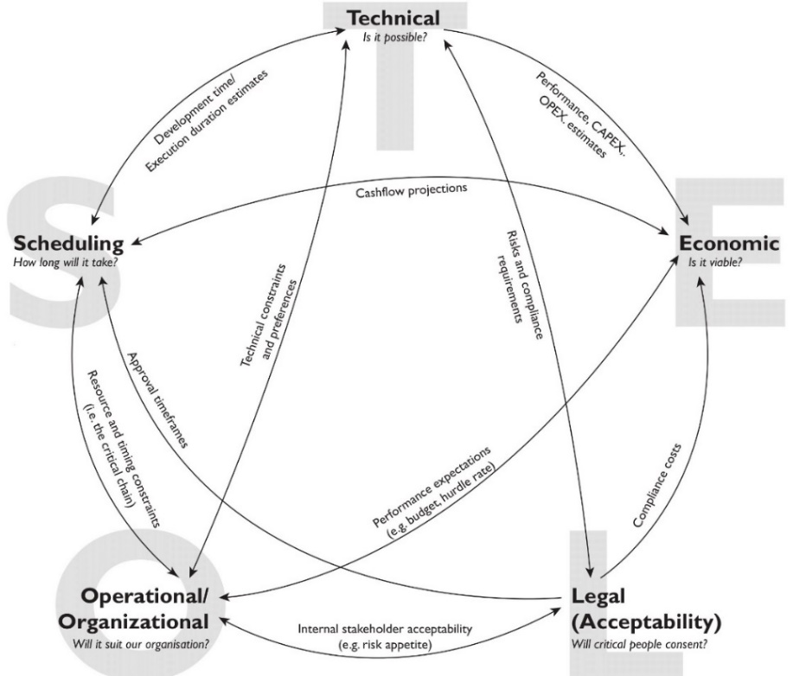

***Figure 3.*** Visualizing the TELOS Framework by McLeod, 2021

Additionally, the proposed project is technically possible and is an existing concept. The technology needed for the development is also available, and most of the tools are accessible and open-source. The researcher has a substantial background for some of the necessary technical requirements and has earned a Responsive Web Design certificate (Larson, 2021) for the knowledge and skills consideration. However, in some unforeseen circumstances where the requirements were beyond the researcher's aptitude, the researcher can adopt an alternative to fulfill the specific requirement. Thus, considering all of these, it is technically possible to develop the proposed project. From all the areas of TELOS, the project will be heavily scoped on the technical feasibility.Specifically, the following are the foreseen bare minimum software that is essential: Integrated Development Environment (IDE), Prototyping Tool and Graphics Editor, and Web Browser.

**Development Stage.** The researcher has defined the development phases in every part of the COVID Pulse web application. Every stages involves the development of the specific feature of COVID pulse through the implementation and coding of the designed project. In other words, this is the primary stage in the realization of the COVID Pulse web application design and translating it into a source code. Each module that will be designed in the designing stage by the researcher will be implemented and coded. After the development stage, the researcher will test the module functionality and determine whether it is appropriately working through end-to-end (E2E) testing. Each development phase will focus on the three segments: Frontend, API (Middleware), and Backend.

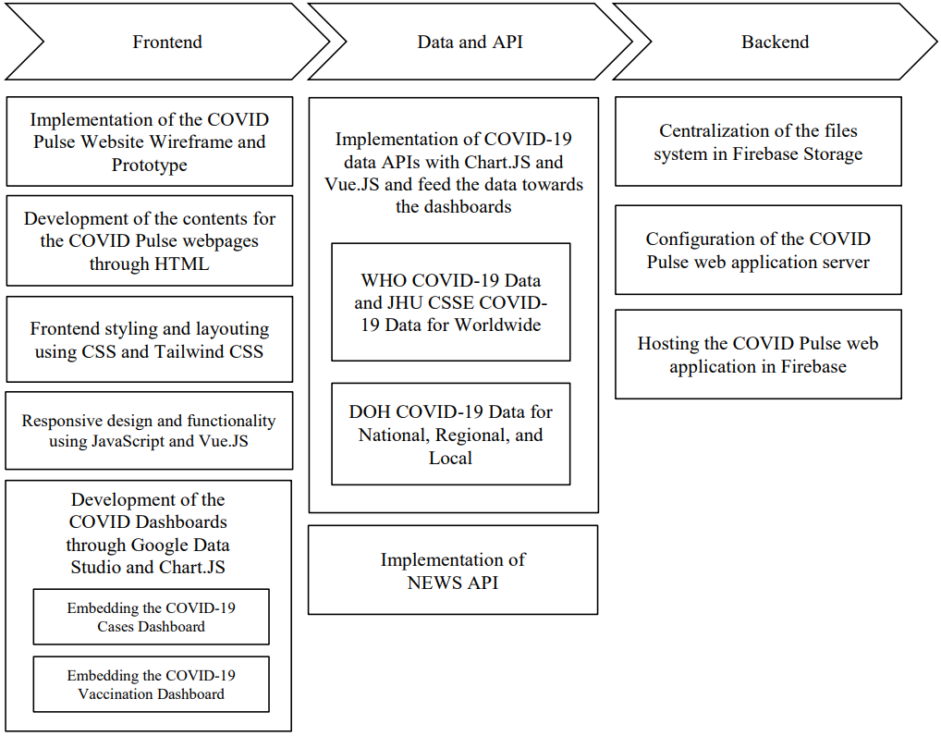

***Figure 8.*** Simplification of the Envisioned Development Phases

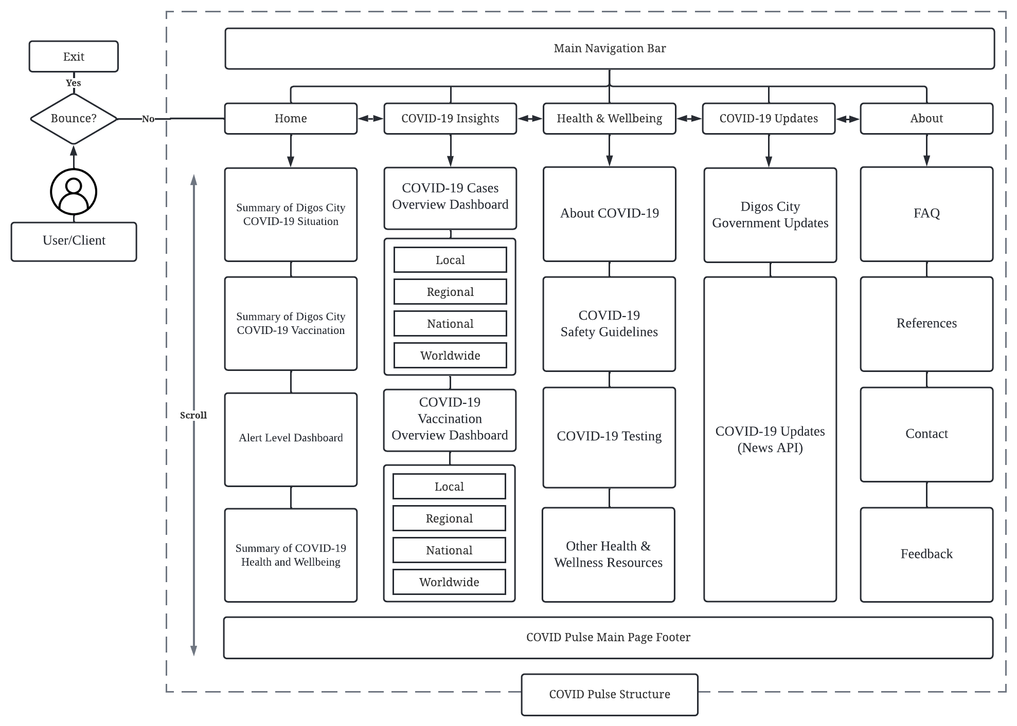

***Figure 4.*** COVID Pulse Website Application Sitemap Structure

**Home** - The home webpage will act as the website's beginning point. The default page loads when the target users, such as the Digoseños, visit the COVID Pulse website.

**COVID-19 Insights** -This webpage will contain the main objective of this project. The elaborated COVID-19 dashboard that visualizes the COVID-19 Cases and Vaccination per segment will be embedded in the said webpage.

**Health & Wellbeing** -This webpage will contain information about the SARS-CoV-2 virus, COVID-19 safety guidelines, COVID-19 testing, and other health-related resources.

**COVID-19 Updates** -This webpage will contain the essential updates from the Digos City government, such as the Alert Level ordinance, and will also contain the COVID-19 related news articles for the Digoseños to be constantly updated and informed.

**About -** The purpose of this web page is to inform the web application visitors about the COVID Pulse's details and the web application's critical operations.

**System Design.** The designing stage is crucial for the development of the COVID Pulse. In this stage, the researcher will identify and describe the web application's features, operation, and specification to establish the intended objectives. The system designing of the COVID pulse will consist of various design considerations and concepts. Additionally, it conceptualizes and offers good visual and descriptive prospects about the web application and its system aspects to allow the final version to be consistent with design structures as described initially in the proposed system architecture models. Hence, this stage is necessary since it will allow the researcher to implement and code the devised and analyzed prospects in the Planning and Analysis phase through a programming language. Lastly, the web application system design of COVID Pulse will be divided into three segments: Frontend, Backend, and APIs.

**Frontend Prototyping.** The initial but most crucial phase of the design stage of the development process is prototyping the COVID Pulse web application. The researcher will be able to ideate the reference for the end product, which allows the development process to be convenient and reduce the cost and time as it provides a comprehensive high-level reference and overview of the final output. Furthermore, the prototyping phase will allow the researcher to make quick necessary modifications and be flexible with the User Interface and User Experience design. Through wire framing, the prototyping will be done through Low-Fidelity and Hi-Fidelity prototypes (Figures 4 and 5). Although sketching is often part of the prototyping procedure, it was not included since it is deemed unnecessary.

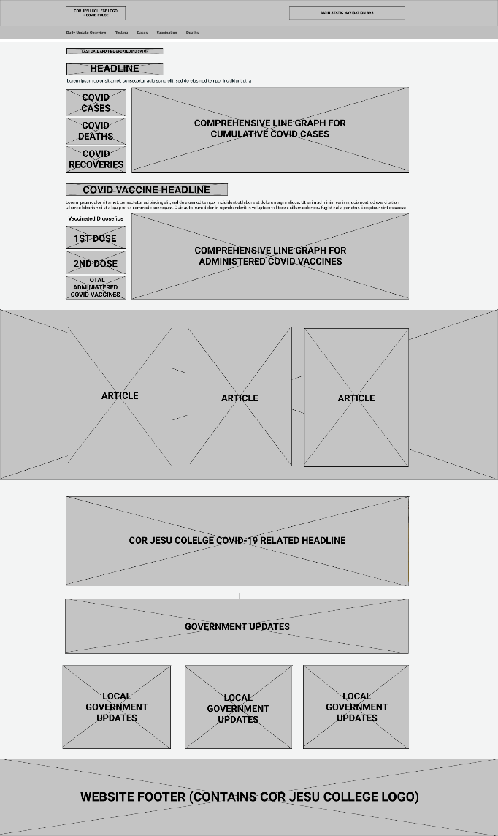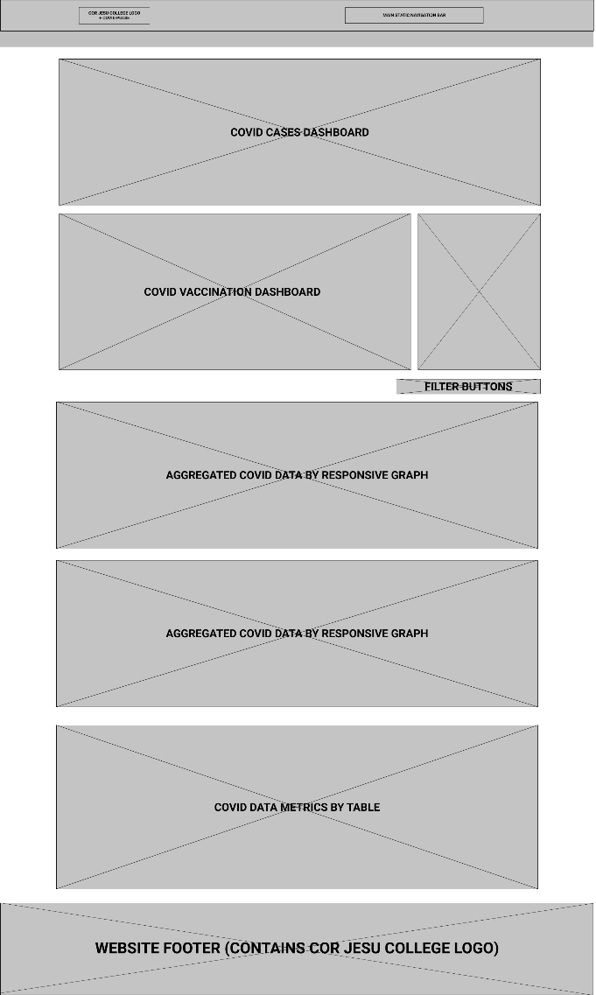

***Figure 5.*** Low-Fidelity Sample of Provisional Wireframe: COVID Pulse  
Home [First Section] and COVID-19 Insights Webpages [Second Section]

Low-fidelity (Lo-Fi) prototyping is essential for the researcher to quickly conceptualize the COVID pulse's design features. However, the appearance design will be disregarded in low-fidelity prototyping (Figure 4). This type of prototyping technique will allow the researcher to convert the high-level design concept of the web application into a testable functional prototype and know each purpose of the components. Then, the low-fidelity prototype will be anchored to the next prototyping stage, which is the high-fidelity prototyping technique. See Figure 6 for a hi-fidelity sample of COVID Pulse.

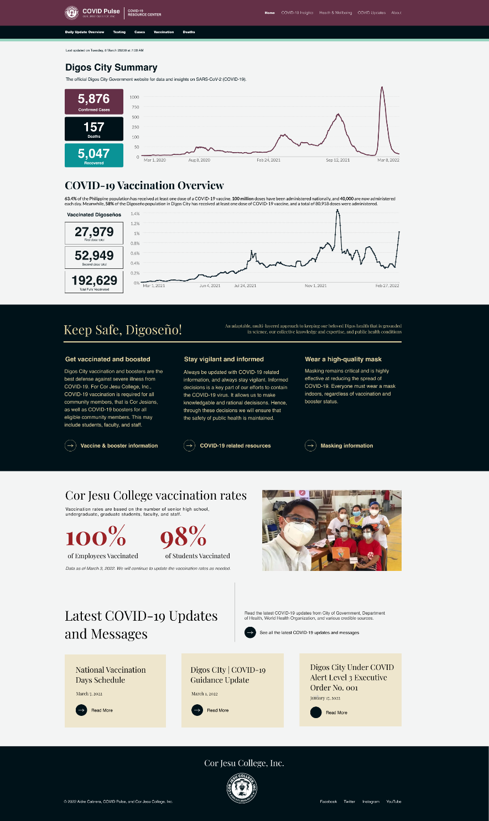

***Figure 7.*** Provisional Sample of the COVID Pulse Home Page (1920 x 3224)

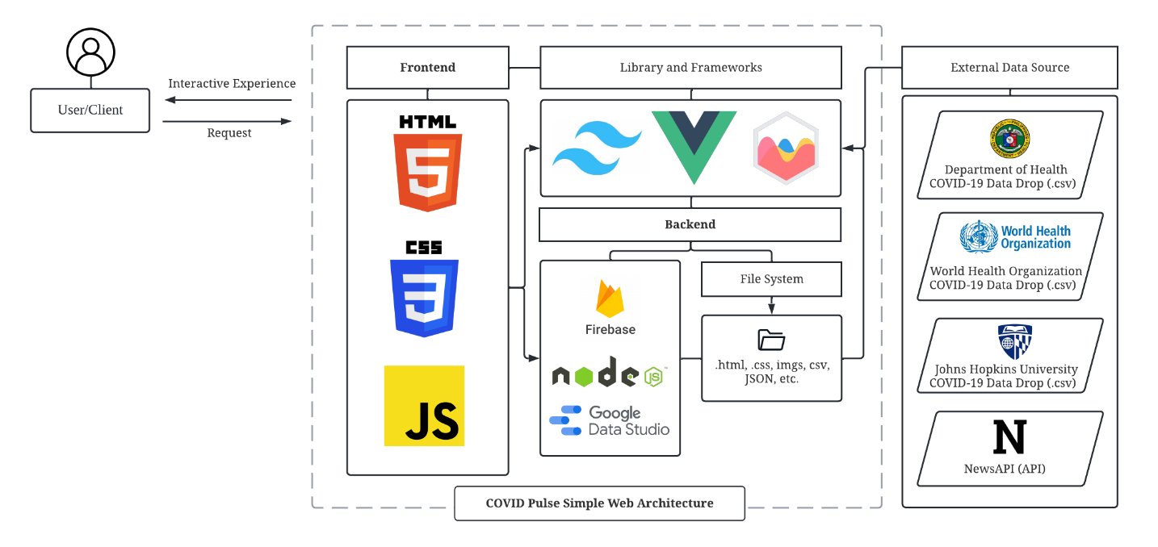

***Figure 9.*** Envisioned COVID Pulse designed web architecture,  
which consists of Frontend, Backend, and APIs

**Frontend and Backend Layer.** The outer layer of the web application project that the Digoseños (Users) see and interact with is the Frontend, also known as the client-side. Specifically, it is the visual elements such as the User Interface (UI) and User Experience (UX) designing of COVID Pulse. The backend layer is scoped on the server-side of the web application, in which the primary purpose is to make sure everything of the web application is functional. Also, it is the part where the clients of the COVID Pulse will not interact and cannot be interacted with users.

The frontend layer will consist of the languages that are the fundamental pillars for Web Development: HTML, CSS, and JavaScript. The researcher will adopt JavaScript and other frameworks and libraries for the backend. Additionally, the researcher will implement tools, frameworks, and libraries such as Tailwind CSS, Vue.js, Chart.js, Cypress, Lighthouse and Firebase during the COVID Pulse web application development.

**Software Configuration**

**Hypertext Markup Language (HTML).** It is the fundamental building block of the webpage since it allows the researcher to define the structure and modules of web content. Therefore, HTML is crucial for the COVID Pulse web application since it will contain the websites' basic text and hypertext contents. However, HTML is always a tandem with CSS.

**Cascading Style Sheets (CSS).** CSS will always coincide with HTML for the researcher to style and specify how the presentation of the User Interface will look (i.e., colors, fonts, and layout) and feel and how the primary contents of the COVID Pulse web application are presented to Digoseños.

**JavaScript.** This programming language is a dynamic client-side scripting that will allow the researcher to make the COVID Pulse web application include more functionality, responsiveness, and dynamic features. Although sufficient, developing the frontend design with Vanilla JavaScript and Vanilla CSS, plain JavaScript or CSS without any libraries or frameworks, is arduous, time-consuming, inefficient, and risky (Delaney, 2021). For instance, for Vanilla CSS, the semantic class names make maintaining it laborious and time-consuming (Hovhannisyan, 2021). This decision will also abide by one of the primary system design principles that will be adopted in the system design. That is, it "should not reinvent the wheel" (Davis, 1995). Hence, it is necessary to implement libraries and frameworks.

**Tools, Libraries, and Frameworks.** The dependencies and devDependencies that will be implemented in the COVID Pulse project can be found in the package.json file found in the repository. It contains the metadata relevant to the COVID Pulse project repository. It will be used for managing the COVID Pulse project's dependencies, devDependencies, scripts, and version. Note that there are some packages such as day.js and axios that were installed during the pre-development and configuration of the project requirements. The following is the tentative configuration of the project:

{

"name": "coronaviruspulse-app",

"version": "0.0.0",

"scripts": {

"dev": "vite",

"build": "vite build",

"preview": "vite preview --port 5050",

"test:e2e": "start-server-and-test preview http://127.0.0.1:5050/ 'cypress open'",

"test:e2e:ci": "start-server-and-test preview http://127.0.0.1:5050/ 'cypress run'",

"test:unit": "cypress open-ct",

"test:unit:ci": "cypress run-ct --quiet --reporter spec"

},

"dependencies": {

"axios": "^0.26.1",

"bootstrap": "^5.1.3",

"chart.js": "^3.7.1",

"dayjs": "^1.11.1",

"jquery": "^3.6.0",

"newsapi": "^2.4.1",

"smooth-scrollbar": "^8.7.4",

"title-case": "^3.0.3",

"vue": "^3.2.33",

"vue-chartjs": "^4.0.7",

"vue-number-animation": "^1.1.2",

"vue-router": "^4.0.14"

},

"devDependencies": {

"@cypress/vite-dev-server": "^2.2.2",

"@cypress/vue": "^3.1.1",

"@tailwindcss/typography": "^0.5.2",

"@vitejs/plugin-vue": "^2.3.1",

"autoprefixer": "^10.4.5",

"cypress": "^9.6.0",

"postcss": "^8.4.12",

"start-server-and-test": "^1.14.0",

"tailwindcss": "^3.0.24",

"vite": "^2.9.6"

}

}

**Node.js Installation** – As of writing, the Node.js version that will be used in the development of the COVID Pulse will be version 16.14.2. The installation of Node.js and Node Package Manager is straightforward. The Windows Installer (.msi) node-v[version-here]-x64.msi was downloaded from the official Node.js website.

1. Downloading the Node.js Installer for Windows
2. Running the Node.js installation
3. Installation will include Chocolatey
4. Restarting the System

**npm -** It is a package manager for the JavaScript programming language maintained by npm, Inc. npm is the default package manager for the JavaScript runtime environment Node.js. It consists of a command line client, also called npm, and an online database of public and paid-for private packages, called the npm registry. Note that the Node.js installation procedure comes with the Node Package Manager (npm). However, for the COVID Pulse project, the researcher further installed the alternative of npm, which is pnpm.

The package manager such as pnpm is essential in the setup and development process of the COVID Pulse project since it allows the researcher to install, update, and remove the packages that is involved during the development process. pnpm will be mainly used since it has major advantages compared to the default package manager of Node.js.

Installation of pnpm via npm:

* cd ./aidrecabrera/cjc-coronavirus-pulse
* npm install -g pnpm

**Vue.js -** The main JavaScript framework that will be utilized to build the COVID Pulse frontend user interface. Vue.js is anchored in the standard HTML, CSS, and Javascript while allowing the resesarcher to develop the project while integrating the declarative and reactive nature of the framework. Furthermore, it is a simple framework unlike Angular.js and React.js while allowing the COVID Project to progress and scale up overtime. Therefore, it is a progressive and save time during the development since it is a progressive JavaScript framework that allows the process to be smooth and easy with a shallow learning curve. Furthermore, it is chosen since it is a suitable lightweight, flexible, modular, and highly performant framework.

Vue.js installation via pnpm:

* cd ./aidrecabrera/cjc-coronavirus-pulse
* pnpm init vue@latest
* (The command will execute *create-vue*)

Configuration of COVID Pulse project through Vue project scaffolding tool:

✔ Project name: …

* cjc-coronavirus-pulse

✔ Add TypeScript? …

* No

✔ Add JSX Support? …

* No

✔ Add Vue Router for Single Page Application development? …

* Yes

✔ Add Pinia for state management? …

* No

✔ Add Vitest for Unit testing? …

* No

✔ Add Cypress for both Unit and End-to-End testing? …

* Yes

✔ Add ESLint for code quality? …

* Yes

✔ Add Prettier for code formatting? …

* Yes

Scaffolding project in ./< cjc-coronavirus-pulse>...

Done.

* cd ./cjc-coronavirus-pulse

**Tailwind -** It is a utility-first framework of CSS that is parceled with classes, enabling faster development of the frontend layer. Other than the time-saving procedure of Tailwind during the development process, it also provides other benefits such as symmetrical layouts, high productivity, and efficiency of the development of the COVID Pulse web application.

Tailwind CSS installation via pnpm:

* cd ./aidrecabrera/cjc-coronavirus-pulse
* pnpm install -D tailwindcss
* pnpx tailwindcss init

**Chart.js -** It is an open-source JavaScript data visualization library that will be adopted. Unlike the other leading data visualization library such as D3.js, Chart.js is straightforward, requires less effort, and sufficed the bare minimum requirement of generating data graphics to develop the COVID-19 dashboard. Furthermore, it will also be paired with Google Data Studio as a complementary for converting the COVID-19data into reports.

Chart.js and vue-chartjs wrapper installation via pnpm:

* cd ./aidrecabrera/cjc-coronavirus-pulse
* npm install vue-chartjs chart.js

Integration of Chart.js to Vue integration:

* import Chart from 'chart.js/auto'

**Firebase -** It is a platform develop by Google that provides development services. The researcher will mainly utilize Firebase services such as Firebase Hosting and to build and monitor the COVID Pulse web application.

Installation of Firebase via pnpm:

$ pnpm install firebase-tools

$ pnpm install firebase

Configuration of Firebase for COVID Pulse project:

$ firebase login

$ firebase init

Deployment of COVID Pulse project in Firebase Hosting service:

$ firebase deploy

**Cypress -** It is a frontend end-to-end testing tool. This framework will be used for the testing stage of the COVID Pulse application. Cypress was picked as the testing tool for the project since it has major advantages when it comes to simplicity and acquiring quick, consistent, and reliable testing process. Cypress has features that enables the researcher to take snapshots during the testing process. It also has debugability that allows debugging process more quick. Additionally, unlike the other testing tools, it has Automatic Waiting, where Cypress does not need any programmatic asynchronous promises. In addition, it has a documentation feature which allows the researcher to take screenshots and record the duration of the testing process automatically. When it comes to consistency, it has an architecture that allows the teesting to quick, consistent, and reliable. Hence, Cypress will be used as a tool for testing the COVID Pulse web application since it allows the researcher to execute automated web application debugging and testing of COVID Pulse project.

Installation of Cypress through pnpm:

* cd ./aidrecabrera/cjc-coronavirus-pulse
* pnpm install cypress --save-dev
* pnpm i -D @cypress/webpack-dev-server @cypress/vue

**Lighthouse.** It is an automated tool for testing web pages and web applications developed by Google. Lighthouse is usually used for acquiring performance metrics and insights for web developers to abide development practices. It has various available features that is useful for identifying the overall aspects of the COVID Pulse web application.

Installation of Lighthouse through pnpm:

* cd ./aidrecabrera/cjc-coronavirus-pulse
* pnpm install lighthouse -g

**COVID Data APIs.** The data dashboard will acquire the COVID-19 aggregated epidemiological data from various APIs in terms of Local, Regional, National, and Worldwide. Specifically, the data source will be from the following repositories:

**JHU CSSE COVID-19 Data -** It is a COVID-19 data repository collected, provided, and operated by the Center for Systems Science and Engineering from Johns Hopkins University. It is publicly available for everyone to be accessed from the GitHub JHU CSSE repository.

**WHO COVID-19 Data -** It is the official COVID-19 data source aggregated by the World Health Organization and is distributed by comma-separated values (CSV) files.

**DOH COVID-19 Data -** The official COVID-19 data source aggregated by the Department of Health can be accessed through the DOH Data Drop.

**List of installed dependencies and devDependencies:**

coronaviruspulse-app@0.0.0 T:\coronaviruspulse\coronaviruspulse-app

├── @cypress/vite-dev-server@2.2.2 -> .\node_modules\.pnpm\@cypress+vite-dev-server@2.2.2_vite@2.9.6\node_modules\@cypress\vite-dev-server

├── @cypress/vue@3.1.1 -> .\node_modules\.pnpm\@cypress+vue@3.1.1_cypress@9.6.0+vue@3.2.33\node_modules\@cypress\vue

├── @firebase/analytics-types@0.7.0 extraneous -> .\node_modules\.pnpm\@firebase+analytics-types@0.7.0\node_modules\@firebase\analytics-types

├── @firebase/app-check-interop-types@0.1.0 extraneous -> .\node_modules\.pnpm\@firebase+app-check-interop-types@0.1.0\node_modules\@firebase\app-check-interop-types

├── @firebase/app-check-types@0.4.0 extraneous -> .\node_modules\.pnpm\@firebase+app-check-types@0.4.0\node_modules\@firebase\app-check-types

├── @firebase/app-types@0.7.0 extraneous -> .\node_modules\.pnpm\@firebase+app-types@0.7.0\node_modules\@firebase\app-types

├── @firebase/auth-interop-types@0.1.6 extraneous -> .\node_modules\.pnpm\@firebase+auth-interop-types@0.1.6_a64185e619fe35b9275fc3c76f6268db\node_modules\@firebase\auth-interop-types

├── @firebase/auth-types@0.11.0 extraneous -> .\node_modules\.pnpm\@firebase+auth-types@0.11.0_a64185e619fe35b9275fc3c76f6268db\node_modules\@firebase\auth-types

├── @firebase/database-types@0.9.7 extraneous -> .\node_modules\.pnpm\@firebase+database-types@0.9.7\node_modules\@firebase\database-types

├── @firebase/firestore-types@2.5.0 extraneous -> .\node_modules\.pnpm\@firebase+firestore-types@2.5.0_a64185e619fe35b9275fc3c76f6268db\node_modules\@firebase\firestore-types

├── @firebase/functions-types@0.5.0 extraneous -> .\node_modules\.pnpm\@firebase+functions-types@0.5.0\node_modules\@firebase\functions-types

├── @firebase/messaging-interop-types@0.1.0 extraneous -> .\node_modules\.pnpm\@firebase+messaging-interop-types@0.1.0\node_modules\@firebase\messaging-interop-types

├── @firebase/performance-types@0.1.0 extraneous -> .\node_modules\.pnpm\@firebase+performance-types@0.1.0\node_modules\@firebase\performance-types

├── @firebase/remote-config-types@0.2.0 extraneous -> .\node_modules\.pnpm\@firebase+remote-config-types@0.2.0\node_modules\@firebase\remote-config-types

├── @firebase/storage-types@0.6.0 extraneous -> .\node_modules\.pnpm\@firebase+storage-types@0.6.0_a64185e619fe35b9275fc3c76f6268db\node_modules\@firebase\storage-types

├── @tailwindcss/typography@0.5.2 -> .\node_modules\.pnpm\@tailwindcss+typography@0.5.2_tailwindcss@3.0.24\node_modules\@tailwindcss\typography

├── @types/duplexify@3.6.1 extraneous -> .\node_modules\.pnpm\@types+duplexify@3.6.1\node_modules\@types\duplexify

├── @types/long@4.0.2 extraneous -> .\node_modules\.pnpm\@types+long@4.0.2\node_modules\@types\long

├── @types/sinonjs__fake-timers@8.1.1 extraneous -> .\node_modules\.pnpm\@types+sinonjs__fake-timers@8.1.1\node_modules\@types\sinonjs__fake-timers

├── @types/sizzle@2.3.3 extraneous -> .\node_modules\.pnpm\@types+sizzle@2.3.3\node_modules\@types\sizzle

├── @types/yauzl@2.10.0 extraneous -> .\node_modules\.pnpm\@types+yauzl@2.10.0\node_modules\@types\yauzl

├── @vitejs/plugin-vue@2.3.1 -> .\node_modules\.pnpm\@vitejs+plugin-vue@2.3.1_vite@2.9.6+vue@3.2.33\node_modules\@vitejs\plugin-vue

├── ast-types@0.13.4 extraneous -> .\node_modules\.pnpm\ast-types@0.13.4\node_modules\ast-types

├── autoprefixer@10.4.5 -> .\node_modules\.pnpm\autoprefixer@10.4.5_postcss@8.4.12\node_modules\autoprefixer

├── axios@0.26.1 -> .\node_modules\.pnpm\axios@0.26.1\node_modules\axios

├── bootstrap@5.1.3 -> .\node_modules\.pnpm\bootstrap@5.1.3\node_modules\bootstrap

├── chart.js@3.7.1 -> .\node_modules\.pnpm\chart.js@3.7.1\node_modules\chart.js

├── check-more-types@2.24.0 extraneous -> .\node_modules\.pnpm\check-more-types@2.24.0\node_modules\check-more-types

├── cypress@9.6.0 -> .\node_modules\.pnpm\cypress@9.6.0\node_modules\cypress

├── dayjs@1.11.1 -> .\node_modules\.pnpm\dayjs@1.11.1\node_modules\dayjs

├── firebase-tools@10.7.2 -> .\node_modules\.pnpm\firebase-tools@10.7.2\node_modules\firebase-tools

├── firebase@9.7.0 -> .\node_modules\.pnpm\firebase@9.7.0\node_modules\firebase

├── jquery@3.6.0 -> .\node_modules\.pnpm\jquery@3.6.0\node_modules\jquery

├── lodash._objecttypes@2.4.1 extraneous -> .\node_modules\.pnpm\lodash._objecttypes@2.4.1\node_modules\lodash._objecttypes

├── newsapi@2.4.1 -> .\node_modules\.pnpm\newsapi@2.4.1\node_modules\newsapi

├── postcss@8.4.12 -> .\node_modules\.pnpm\postcss@8.4.12\node_modules\postcss

├── smooth-scrollbar@8.7.4 -> .\node_modules\.pnpm\smooth-scrollbar@8.7.4\node_modules\smooth-scrollbar

├── start-server-and-test@1.14.0 -> .\node_modules\.pnpm\start-server-and-test@1.14.0\node_modules\start-server-and-test

├── tailwindcss@3.0.24 -> .\node_modules\.pnpm\tailwindcss@3.0.24\node_modules\tailwindcss

├── title-case@3.0.3 -> .\node_modules\.pnpm\title-case@3.0.3\node_modules\title-case

├── vite@2.9.6 -> .\node_modules\.pnpm\vite@2.9.6\node_modules\vite

├── vue-chartjs@4.0.7 -> .\node_modules\.pnpm\vue-chartjs@4.0.7_chart.js@3.7.1+vue@3.2.33\node_modules\vue-chartjs

├── vue-number-animation@1.1.2 -> .\node_modules\.pnpm\vue-number-animation@1.1.2\node_modules\vue-number-animation

├── vue-router@4.0.14 -> .\node_modules\.pnpm\vue-router@4.0.14_vue@3.2.33\node_modules\vue-router

└── vue@3.2.33 -> .\node_modules\.pnpm\vue@3.2.33\node_modules\vue

**dependencies:**

axios 0.26.1 dayjs 1.11.1 jquery 3.6.0 title-case 3.0.3 vue-number-animation 1.1.2

bootstrap 5.1.3 firebase 9.7.0 newsapi 2.4.1 vue 3.2.33 vue-router 4.0.14

chart.js 3.7.1 firebase-tools 10.7.2 vue-chartjs 4.0.7

**devDependencies:**

@cypress/vite-dev-server 2.2.2 @tailwindcss/typography 0.5.2

cypress 9.6.0 tailwindcss 3.0.24

@cypress/vue 3.1.1 @vitejs/plugin-vue 2.3.1

postcss 8.4.12 vite 2.9.6

@cypress/webpack-dev-server 1.8.4 autoprefixer 10.4.5

start-server-and-test 1.14.0

**Hardware Specification for Development:**

The hardware specification for the computer that will be used in the development of COVID Pulse web application are of the following:

**Computer Hardware Specification for Development:**

* + Processor: AMD Ryzen 3 4300GE with Radeon Graphics 3.50 GHz
  + System Type: 64-bit Operating System, x64-based processor
  + Installed Memory (RAM): 16.0 GB (2x8 DDR4-3200MHz)

**Computer Hardware Specification for Testing:**

* + Processor: Intel® Core(TM) i5-4460 with Intel® HD Graphics 4600 3.20GHz
* System Type: 64-bit Operating System, x64-based processor
* Installed Memory (RAM): 4.0 GB (1x4 DDR3-1600MHz)

**Software Specification for Development:**

The software specification for the computer that will be used during the development of COVID Pulse web application are of the following:

* Windows 10 Professional Edition
* Visual Studio Code (Version 1.66.2, Latest release as of Writing)
* Visual Studio Code Extensions (For development speed):
  + Volar (Version 0.34.11)
  + Tailwind CSS IntelliSense (Version 0.8.3)
  + Auto Close Tag (Version 0.5.14)
  + Auto Rename Tag (Version 0.1.10)
  + ESLint (Version 2.2.2)
  + HTML CSS Support (Version 1.11.0)
* Mozilla Firefox (For CSS-oriented development and testing)
* Microsoft Edge (For main browser for local preview and testing)
  + JSON Formatter Extension
* Adobe Photoshop 2021
* Figma (Latest version as of writing)
* Firebase Hosting Service (Spark plan):
  + Downloads (Bandwidth): 10GB/month
  + Storage: 10GB

**Web Application Testing and Simulation**

The testing stage will be part of the COVID Pulse development process. The project will adopt a type of functional test called End-to-End (E2E) testing, specifically an automated Horizontal E2E. This type of testing involves testing the entire software, or in this case, website web application, from start to end and will coincide with the user flow (Hamilton, 2019). Its primary goal is to test the developed project to validate if everything from all the integrated units is behaving as expected (Figure 4). E2E testing is mainly done from the aspect of the end-user by simulating actual real-world user experience and verifying the entire system.

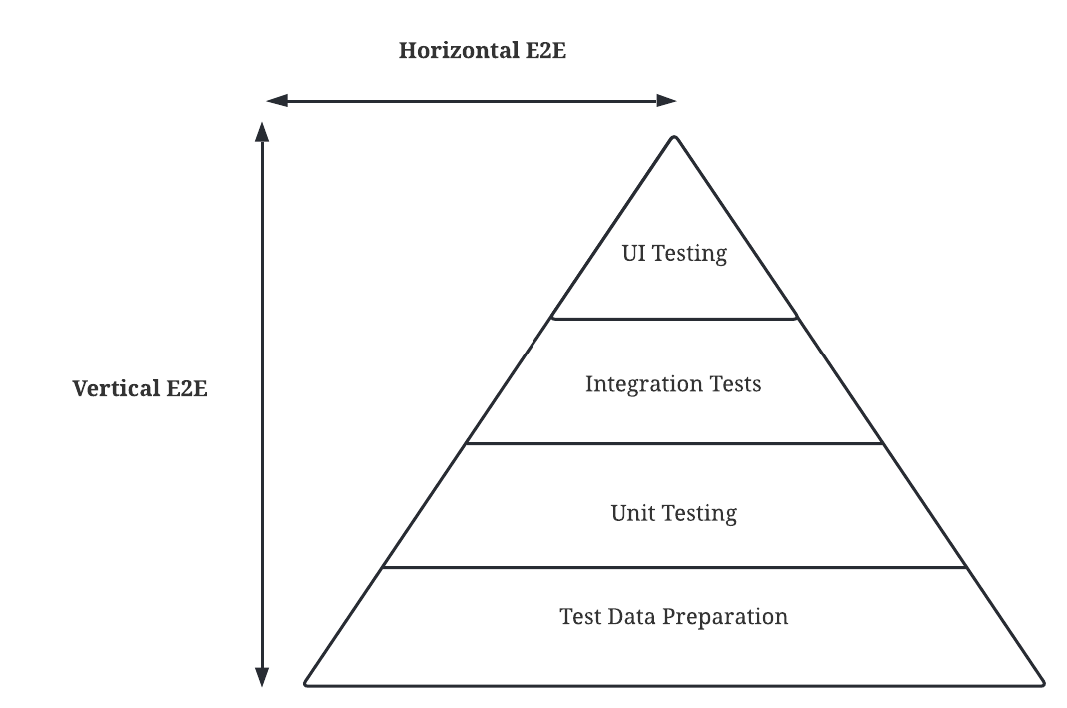

***Figure 10.*** E2E Test Automation Horizontal & Vertical Scale

## Measures

## Procedure

## Data Analysis

CHAPTER IV  
RESULTS AND DISCUSSION

CHAPTER V  
SUMMARY, CONCLUSIONS, AND RECOMMENDATIONS